2nd November 2018

**YOKOHAMA to supply tyres for FIA F3 World Cup in 65th Macau Grand Prix**

YOKOHAMA will supply “ADVAN” racing tyres to the 65th Macau Grand Prix, to be held in Macau (China) 15th-18th November. YOKOHAMA supplied tyres for this event for 33 straight years until 2015 and resumed support last year. This year therefore marks the 35th time YOKOHAMA tyres will speed over the streets of Macau. YOKOHAMA tyres will be the control tyre for the event’s main race, the FIA F3 World Cup, and for the concurrently held FIA World Touring Car Cup (WTCR) race. In addition, they will be the tyre of choice for cars competing in the event’s other races.   
  
The Macau Grand Prix, run on public roads in the city center, is one of the world’s most famous road races. The main F3 Grand Prix race was designated an official FIA world championship race in 2016 and renamed the FIA F3 World Cup. YOKOHAMA began supplying control tyres for the race in 1983, when Formula 3 vehicles meeting international standards began competing in the event. Because the race is held on public roadways, participating vehicles require tyres that provide high performance on surfaces and conditions typical of normal driving conditions, which are quite different from those found on circuit racetracks. Past winners of the F3 race include many drivers who later had successful F1 careers, including in Michael Schumacher in 1990 and Takuma Sato in 2001.

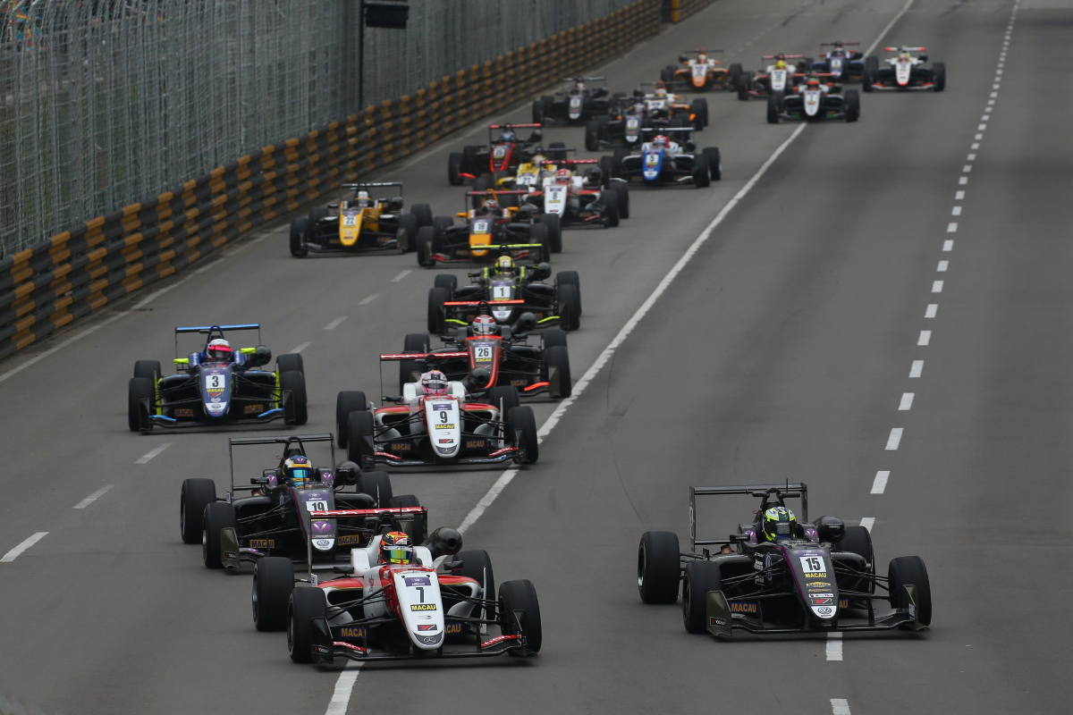

*Macau FIA F3 World Cup (2017)*